SMART CONTACT MANAGER
API -Based Contact Management System TEAM ID: SWTID-2026-5114
TEAM LEADER:
S Dayana(202400786@sigc.edu) TEAM MEMBERS:
A Janani(202400827@sigc.edu) M Harshini(202400878@sigc.edu)
R Archanaa(202400443@sigc.edu)

- Project Overview
SMART Contact Manager is a backend application used to manage and organize contact information in a centralized system.It helps users store,edit,search and delete contacts efficiently. The system is build using node.js,Express.js and MongoDB.

- Objectives
*Provide secure user authentication
*Allow CRUD operations for contacts
*Store data using MongoDB
*Provide fast search and filtering
*Develop scalable REST APIs

- Target Users
*Students
*Freelancers
*Small business owners
*Professional managing networks 4.Technologies Used
Node.js:JavaScript runtime for backend Express.js:Framework for REST APIs
MongoDB:NoSQL database Mongoose:ODM for MongoDB JWT:Authentication system Postman:API testing tool

- System Architecture:
*Client Layer – Sends API requests
*Application Layer – Node.js and Express
*Database Layer – MongoDB

- Core Features
* Users Registration
*User Login
*JWT Authentication
*Create Contact
*View Contact
*Update Contact
*Delete Contact
*Search Contact

- Roles and Responsibilities
*Register account
*Login to system
*Add contacts
*Edit contacts
*Delete contacts
*Search contacts

- Database Design
Users Collection: id,name,email,password,createdAt

Contacts Collection: id,userId,name,email,phone,notes,createdAt

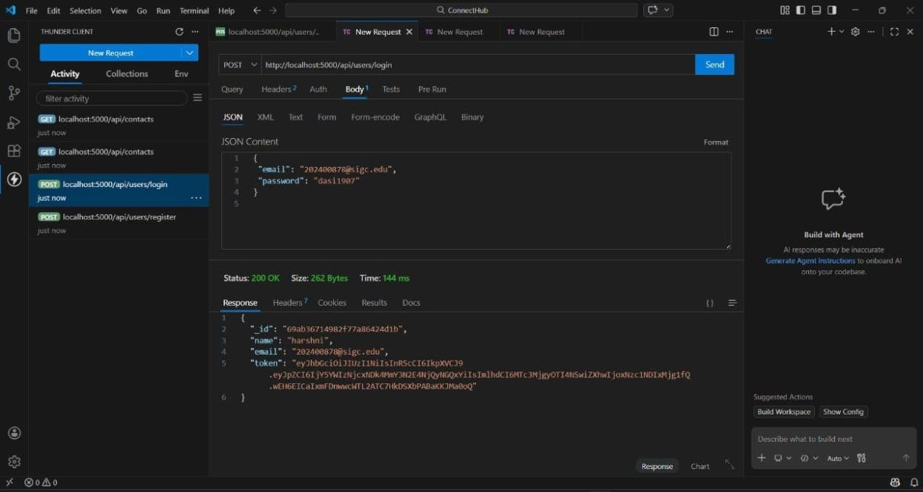
- Screenshots: Login:

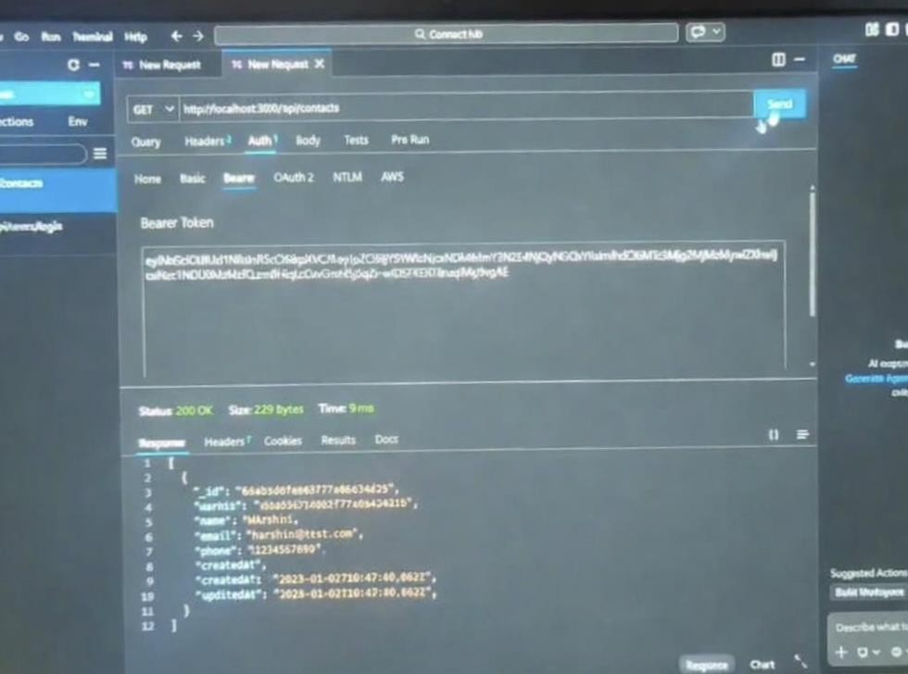
Search:

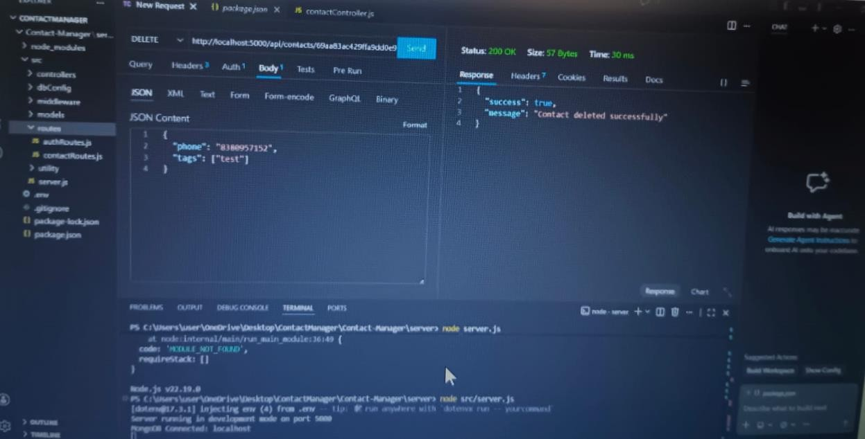
Delete:

Update:

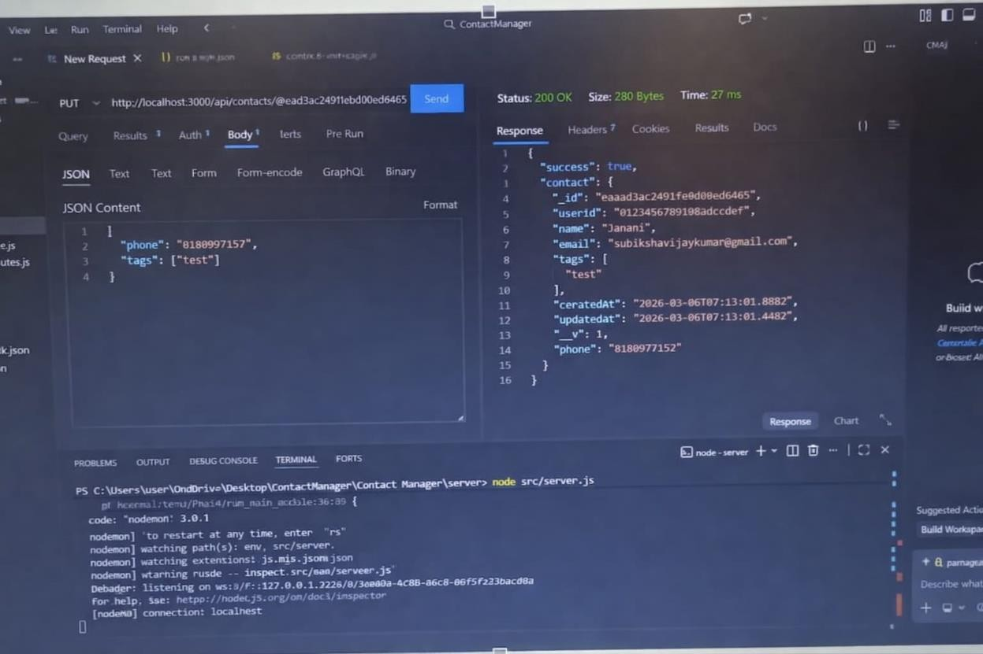

Create New Contact:

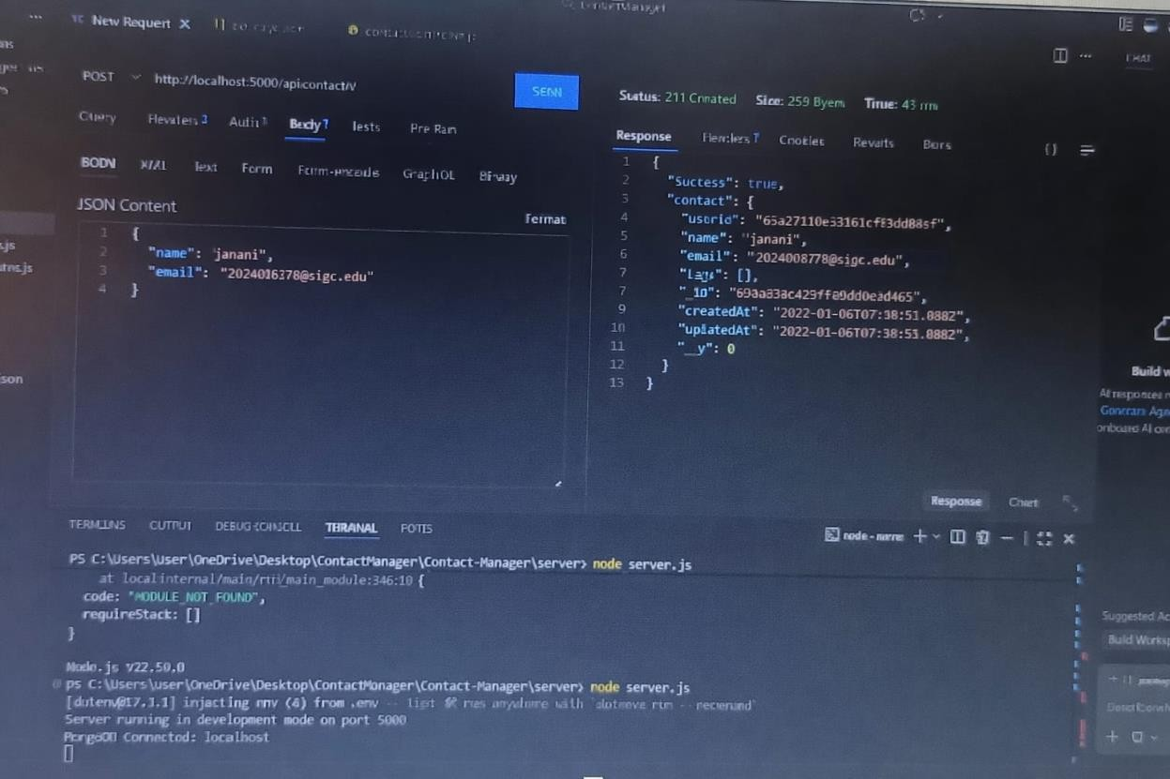

Get The Current Users:

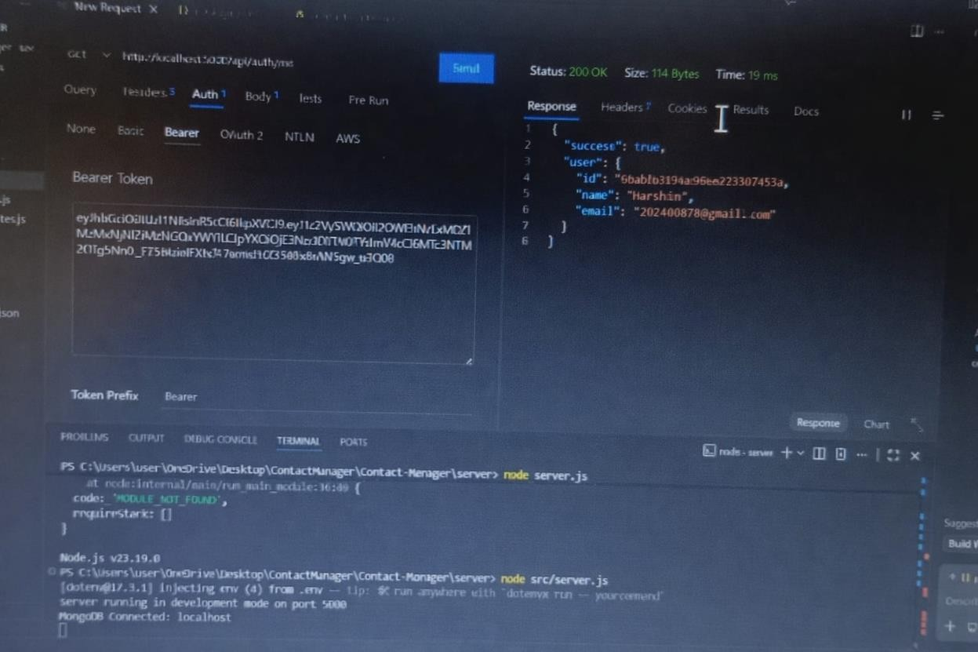
- Project Setup
- Install Node.js
- Initialize project with npm init
- Install dependencies
- Create server file
- Connect MongoDB
- Create API routes
- Test APIs with Postman
- Conclusion
This project demonstrates backend development using Node.js Express and MongoDB to create a secure API-based contact management system.

- Demo link:
https://drive.google.com/file/d/1hdAnNXu0qNJkziRGOW_zLgomMP2npf- v/view?usp=drivesdk

